## Appendix-AI – Bell CHSH inequality links

#### Bells inequality part 1

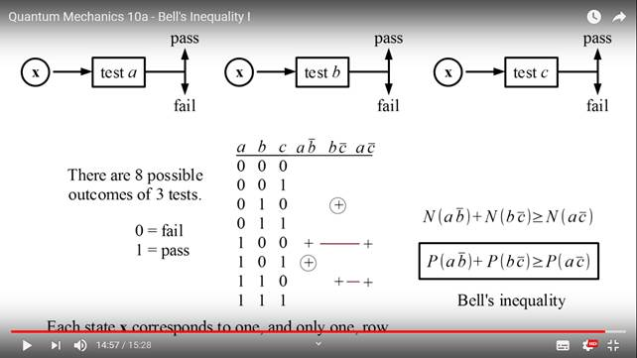

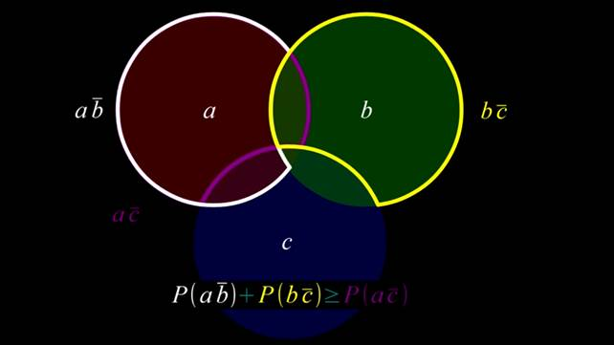

<https://www.youtube.com/watch?v=sAXxSKifgtU>

#### Bells inequality part 2

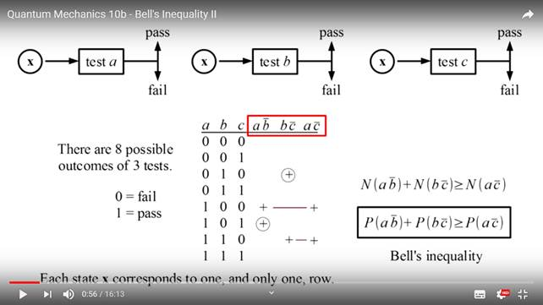

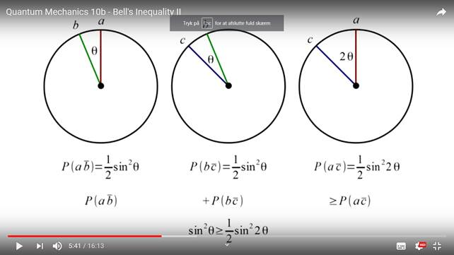

<https://www.youtube.com/watch?v=8UxYKN1q5sI&t=3s>